**Instructional Day:** 17

**Topic Description:** Minimal spanning trees and graphs will be explored. Students will learn how graphs can be used to help solve problems.

**Objectives:**

The students will be able to:

* Solve a minimal spanning tree.
* Draw a graph to solve a problem.

**Outline of the Lesson:**

* CS Unplugged Activity 9: The Muddy City—Minimal Spanning Trees (20 minutes)
* CS Unplugged Activity 9: The Muddy City—Minimal Spanning Trees ( extension) (35 minutes)

**Student Activities:**

* Participate in the various parts of the CS Unplugged: The Muddy City activity.
* Participate in the various parts of the CS Unplugged: The Muddy City activity extension.

**Teaching/Learning Strategies:**

* CS Unplugged: The Muddy City activity
  + The activity can be downloaded from http://csunplugged.com. It will be helpful to read through the entire activity in advance, so that you can revise questions, add your own questions, and think about how you might want to structure each part of the activity. The goal is for students to be actively involved in some way and for all students to be able to describe shortest path strategies. What follows is the minimal suggestion.
  + For visually impaired students we use a tactile graph on paper that allows graph information to be read in printed text and braille as well as providing information through touch by using wikkistix. A sample is included below. The “houses” or cities are represented as circles/spirals with their names written in print and braille next to them. Edges between cities are straight lines made of wikkistix. Their weights are represented by the number of bars going across them, by a printed number, and a braille number near the bars.

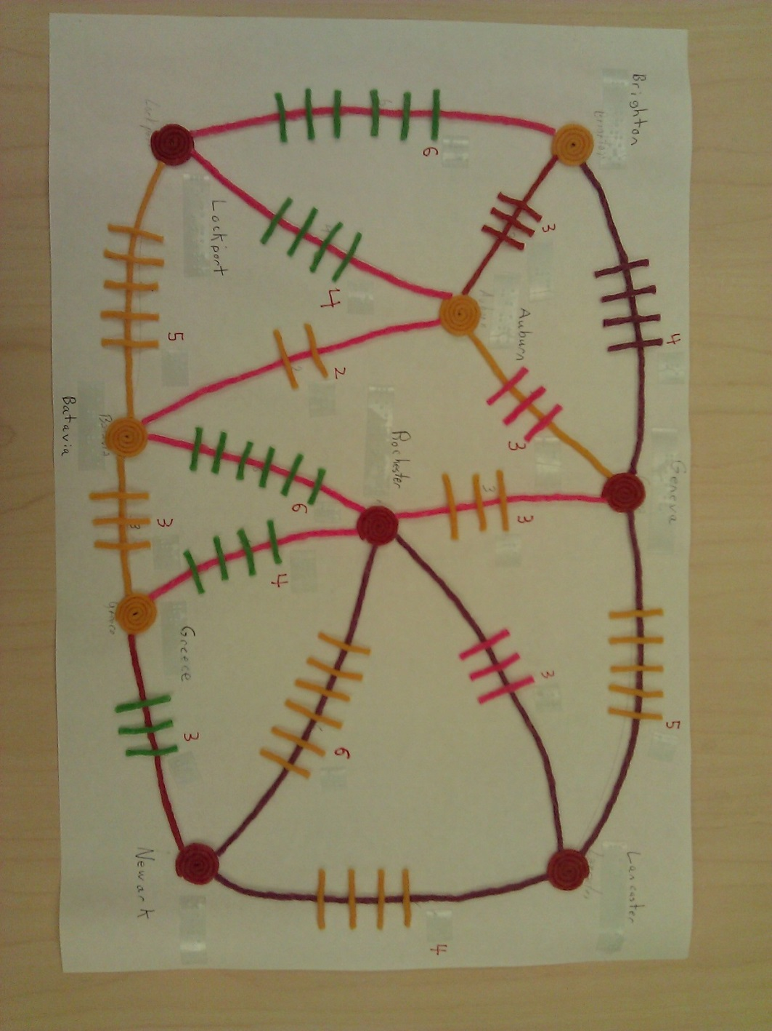

* + Although difficult to see, all of the numbers and names have braille labels next to them.
  + Follow the directions in The Muddy City Problem on p. 78.
  + Have students work with their elbow partners.
  + Have students share their solutions and lead the follow-up discussion p.77.
* CS Unplugged: The Muddy City activity extension
  + Have students repeat the Muddy City Problem with the abstract representation in the figure on p. 79 and answer the questions on p 79.
  + Discuss various applications of this problem in anticipation of the final project (p.80).
  + Emphasize the idea of shortest path

**Resources:**

* Bell, Tim, Ian Witten and Mike Fellows. Computer Science Unplugged. Canterbury, New Zealand: 2002.
* Computer Science Unplugged Activity 9: The Muddy City—Minimal Spanning Trees, pp. 76-80